Ram Bahadur Chettri built a 3-storied residential building, in 964 sq. ft area in Pokhara back in 2073 BS. His ground floor covers 654 sq. ft., 1st floor covers 654 sq. ft. while 2nd and 3rd floor covers 450 sq. ft each. According to Land Revenue Offices net worth of Ram’s land is 30 Lakhs Nepali Rupees. It seems that Ram has not paid is taxes for year 2074 / 2075 and 2075 / 2076.

Ram paid a whole some of Rs. 54,876

Calculation

For year 2074 / 2075

Ground Floor: 654 * 10

First Floor: 654 * 12

Second Floor: 450 * 14

Third Floor: 450 * 15

For year 2075 / 2076

Ground Floor: 654 * 10

First Floor: 654 * 12

Second Floor: 450 * 14

Third Floor: 450 * 15

Total 27,438 Total 27, 438

Pokhara municipality is planning to make a system where it could calculate tax for similar buildings that are built in an area worth 30 Lakhs. Here are new tax regulations formulated by Pokhara Municipality.

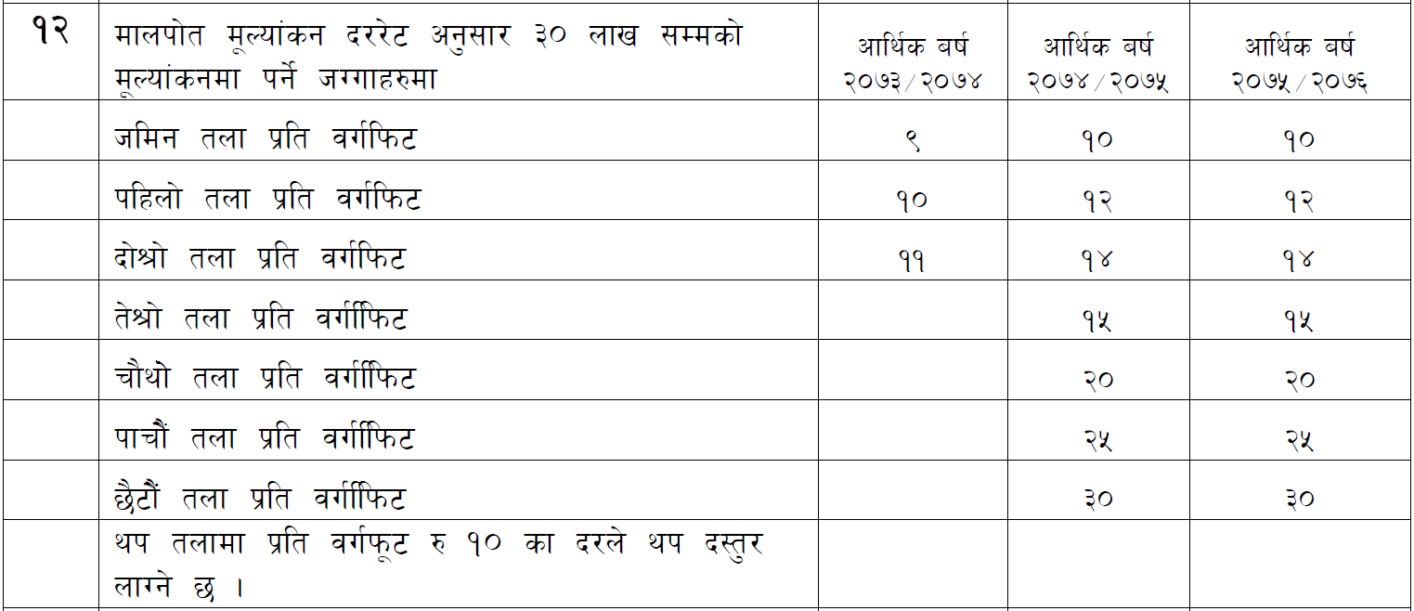

To create this system here are Inputs you need to collect from any citizen who is at Pokhara Municipal Office to pay their taxes.

***How many floors?***

***Surface Area of each floor.***

You need to create a logical system using if…else if…else statement to calculate Total Taxes using all 8 conditions mentioned in above tax rule document.